**ACTIVITY REPORT- (2012-2015)**

**EDUCATION AWARENESS PROGRAMME**

**KNOWLEDGE IS POWER, HARD WORK IS WORSHIP**

**AIMS:**

Creating and establishing educational environment among poor and educationally backward people in the neighboring locality of the premises.

Bringing awareness about importance of education in human society

Restricting children to play in streets, watching excessive TV and wasting time without knowing their aims. Creating moral values among youths will be one of the main aims.

Encouraging people to participate in social activities that benefit masses.

Encouraging the youngsters to join government services particularly Judiciary, army and police so that grievances of backward classes particularly muslims in future may be addressed with justice.

**Target:**

Young children (Class Ist to VIII standard) of at least fifty educationally backward and financially poor families are targeted every year to achieve excel in education and create educational and friendly atmosphere in the society.

By creating competitive atmosphere among students of higher classes (Class IX to XII), and to define their main goal and do efforts to achieve them. Extending all support to promising students. Providing Guidance to at least twenty, XII passed and graduate students to join government services particularly Judiciary, army and police.

**Methodology and Practice:**

By providing free reading room cum library with all facilities like proper sitting arrangement, power backup and a small collection of important books to all class students. This facility is available for twenty four hours to higher class students.

The facility is extended to lower class students with one teacher who is available for four hours daily from 4 pm to 8 pm to assist the young boys and girls in completing their day to day home work.

Time to time the parents are requested to attend the motivating lectures to know how better environment at home may be created to uplift the children in the right direction.

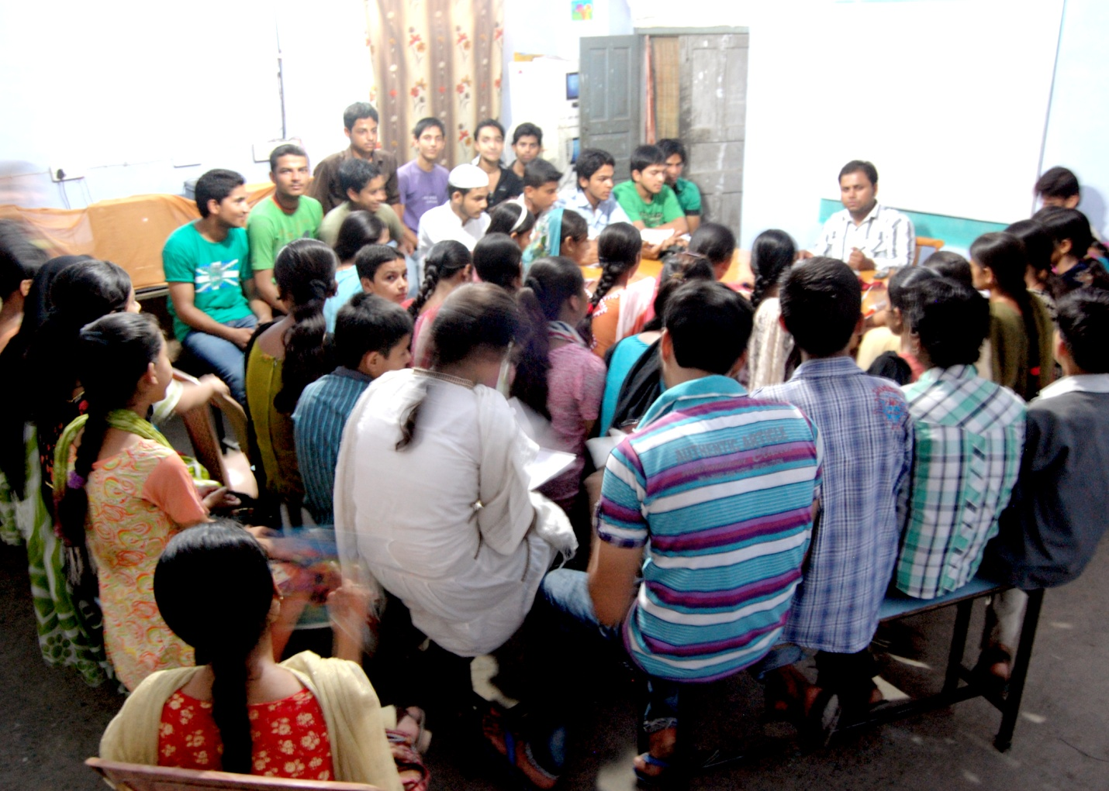

**(2012-2013)**

The library facility remained available for the whole year. Many rounds of interactions with students during past one year are arranged by society executives and motivated them for better quality of education. Few interactive session and expert classes for English, Urdu and Maths for class VI-X were also arranged.

An orientation programme was also organized in which students of A.M.U Aligarh and Jamia Millia Islamia, New Delhi participated. They informed to the students about different courses offered by these institutes and how they may get admission in different courses. The programme was attended by more than 100 students and it was quite encouraging and successful.

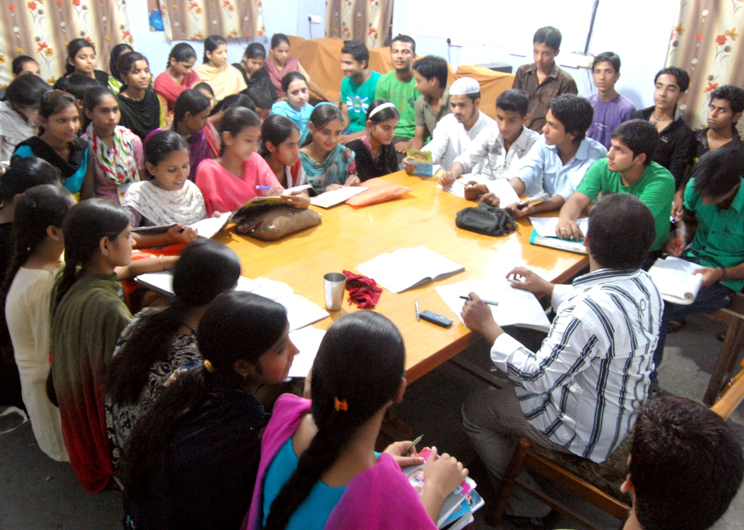

**(2013-2014)**

During 2013-14 due to constraint of funds many activities could not be conducted. However library facility remained available for the students. This library facility is serving the poor students since 2006 and a good number of students have been benefitted during past 8 years. Some students, who were getting benefit of this library got admission in Engineering, Dip Engg and other higher degree programmes in leading institutes of the country.

Time to time society executives interacted with the students and motivated them for better quality of education. Few interactive session and expert classes for English, Urdu and Maths for class VI-X are also arranged.

An orientation programme was also organized on 29th December 2013, in which students of A.M.U Aligarh and Jamia Millia Islamia, New Delhi participated. They informed to the students about different courses offered by these institutes and how they may get admission in different courses. The programme was attended by more than 100 students and it was quite encouraging and successful.

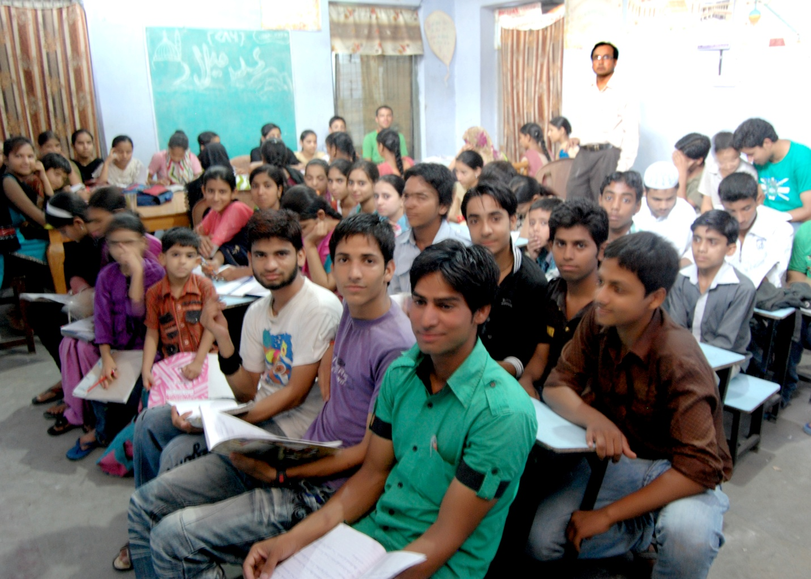

**(2014-2015)**

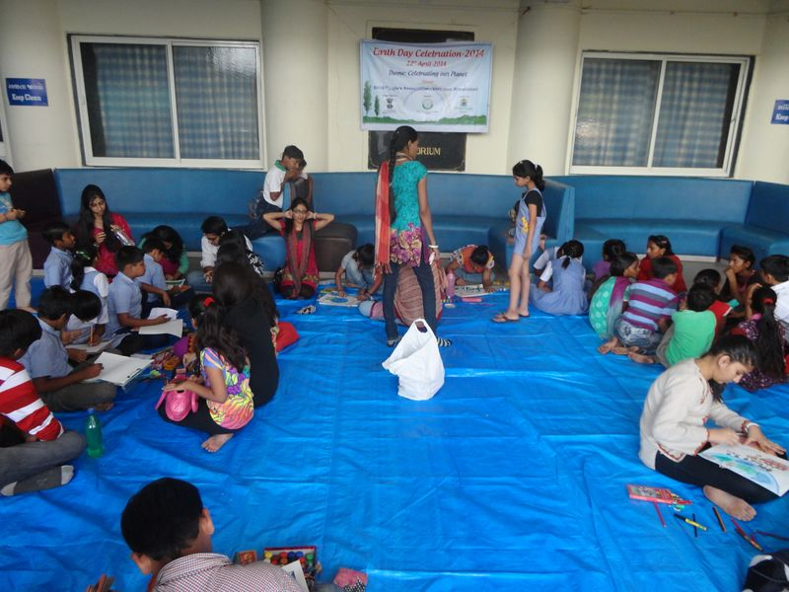During 2013-14 due to constraint of funds many activities could not be conducted. However library facility remained available for the students. This library facility is serving the poor students since 2006 and a good number of students have been benefitted during past 8 years. Some students of this library are doing Engineering, Department Engineering and other higher degree programmes in leading institutes of the country.

**Earth Day Celebration-2014:**

Our Organization worked in association with Science Aur Kainat Society of India which organized Earth Day on 22nd April in Gujrat & Bihar. This programme was organized by Science Aur Kainat Society of India, Catalyzed & Supported by Ministry of Earth Sciences, Govt. of India in association Faith Social And Educational Welfare Society.The programme was conducted at Gaya.

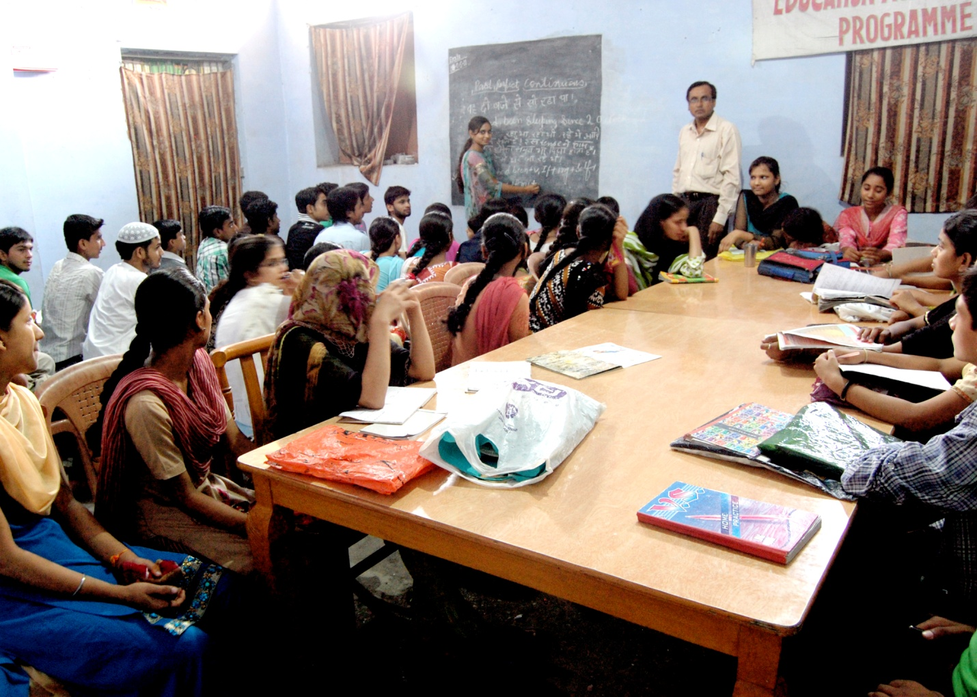

Dr Majid Jamil

Secretary